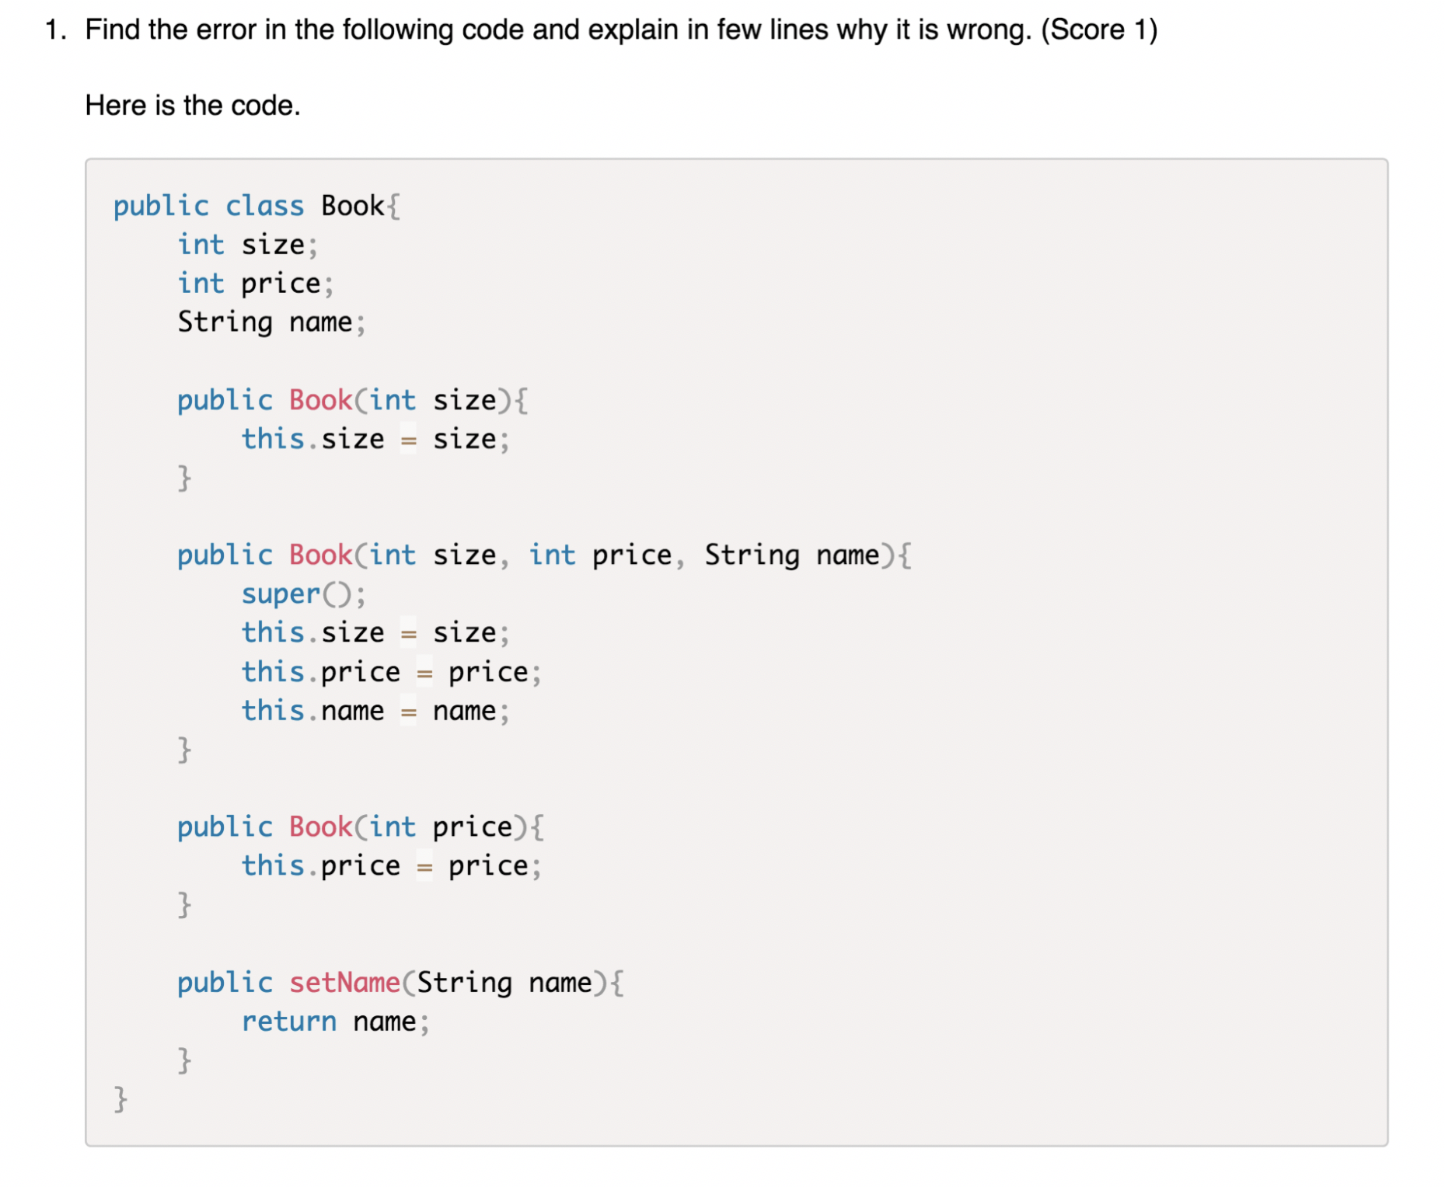

The constructor “public Book(int size) {…}” and the constructor “public Book (int price) {…}” have a same parameter type (int size, int price), so they will be seen as the same constructor.

In constructor “public setName(String name) {…}”, “public setName(String name)” should be “public void setName(String name)”, and “return name;” should be “this.name = name”.



In constructor “void getTime() {…}”, “void getTime( )” should be “String getTime( )”.

3. (scores 2) 1)What will be the output of the following program?

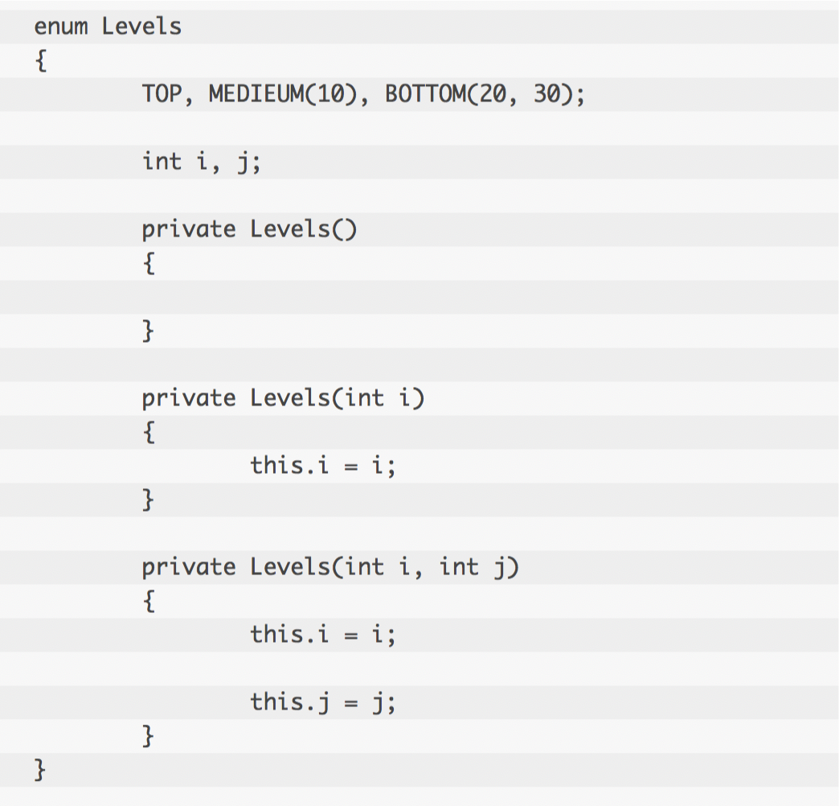 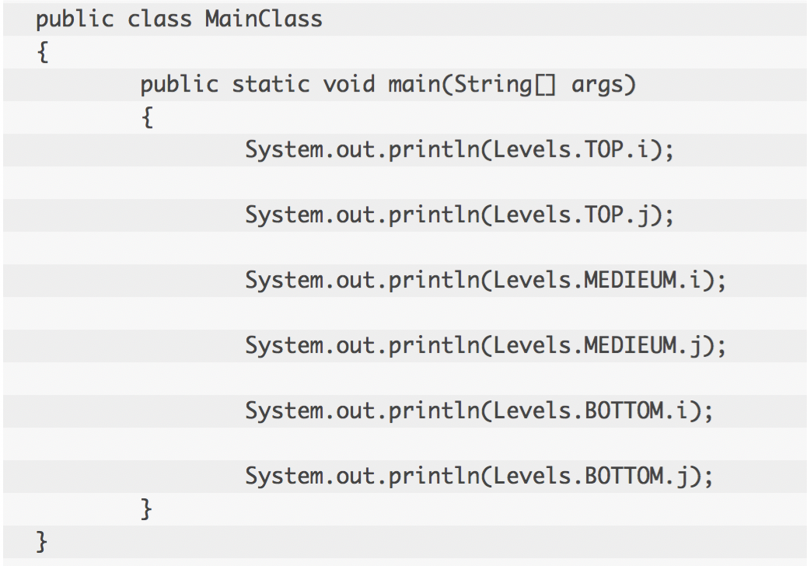

The output should be:

0

0

10

0

20

30

2)Can you find out the error in the below code?

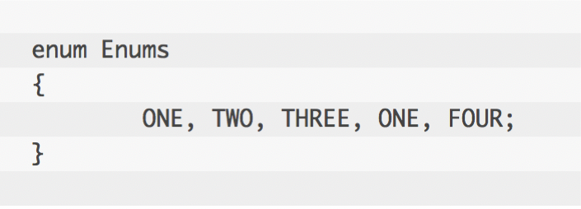

There are two “ONE”s in Enums. The name of fields in enum class should not be duplicate.